SVMC software improvement

DOC. No.: | REV.: 00 |  |  | PRODUCT:
TITLE: SVMC software improvement |  |  |  | Project:
Prepared by: | Donald huang |  |  | Date:
Remark: | Approval:
Remark: |  | Department | Title |  |  | Signature
Remark: | 1 | Electronic R&D
Remark: | 2
Remark: | 3
Remark: | 4

Revision | Description of Change | Author | Date
00 | Initial version | Donald Huang | 5/13/2008
01 | Add step 2 implementation | Donald Huang | 6/17/2008
02 | Remove DBH and build new 485 communication method | Donald Huang | 6/18/2008
03 | Test platform already done, add some implementation projects location. | Donald Huang | 1/9/2009
04 | Add Software quality improvement section | Donald Huang | 1/19/2009

1. Overview 4
1.1. Objective 4
1.2. Scope 4
1.3. Reference 4
1.4. Abbreviations 4
1.5. Overview 4
2. SVMC software architecture 4
2.1. Before improvement 4
2.2. After Improvement 5
3. Test platform 5
3.1. Step 1: test platform core 5
3.1.1. Overview 5
3.1.2. Plan 6
3.1.3. Implementation 6
3.2. Step 2: component test platform 6
3.2.1. Overview 6
3.2.2. Plan 6
3.2.3. Implementation 6
3.3. Step 3: product test platform 7
3.3.1. Overview 7
3.3.2. Implementation 7
4. Software quality improvement 7
4.1. Clean up 7
4.1.1. Clean up unused code 7
4.1.2. Comment 7
4.1.3. Naming 7
4.1.4. Format 7
4.2. Make code high cohesion 7
4.3. Thread safe code 8
4.4. Additional OS API abstract layer 8
4.5. Develop with C++ 8
5. IO board Software update 9
5.1. Before improvement 9
5.2. After improvement 9
5.3. Implementation 9

Overview

Objective

This document describes the consideration, method, steps of SVMC software improvement.

Scope

Before improvement, the scope is IO board software. After improvement, the scope is IO board software, part of main board software and some test software on Windows.

Reference

FB200_analysis.doc
SL15 SW Function Requirement.doc
SL15 SW HLD.doc

Abbreviations

SVMC: Specific Vending Machine Controller
GVMC: General Vending Machine Controller

Overview

There are three major changes for SVMC software improvement.

- Move the MDF file, SVH and tree building to main board application
- Build test platform for component and product.
- Construct new boot loader and download method

The changes bring some merits:

- Cost down the IO board hardware. After the SVMC software improvement, code on IO board will be dramatically cut down. The binary of new IO board software will be small enough to put in the MCU with embedded flash. An external flash chips will be saved.
- New boot loader will share most code with IO board application. This will simplified the code structure and easier for test.
- Cooperated with the control motivated style main UI. SVMC software before improvement is designed for SL GVMC software which use menu and key motivated UI. It uses messages sequences to control the user interface. The SL15 UI is widget based, it use Windows control to interact with SVMC. To move the SVH to main board application, the improved SVMC will work better with the SL15 UI.
- Easier for debug. Most code will be developed cross platform. It can be debugged under Windows. A test platform for component will be build to isolate and fix bugs.

On the other hand, there are demerits:

- More code has to be developed.
- Though unit test will perform for modules, it takes time to make product producing process fully run.
- More communication needed between the IO and main board. If the cup board needed to be connected to the main bus, cup board must implement more communication codes.

SVMC software architecture

Before improvement
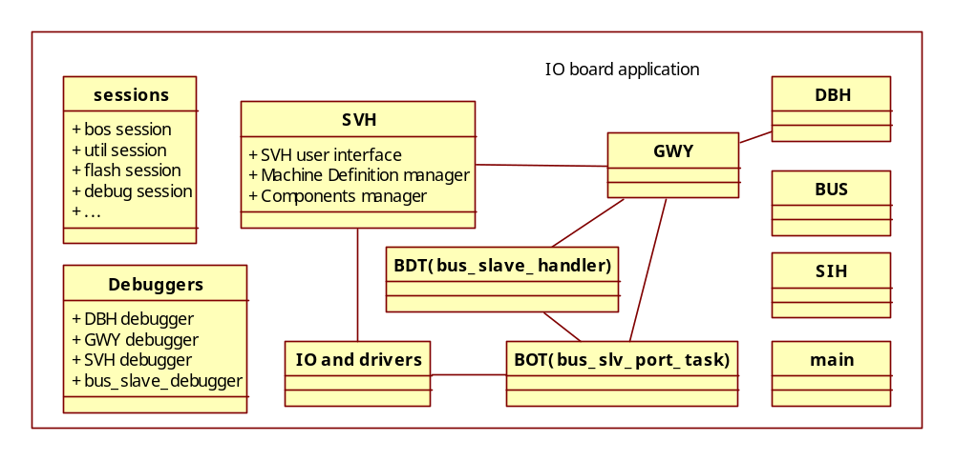
Figure 1

Figure 1 shows the software architecture for SMVC before improvement. All modules of SVMC are in IO board application.

The machine is motivated by IO. Certain set of IO constructs components. So the machine is logically use components to control IO. The components are configurable by a MDF (Machine definition file). The whole SVMC serves the MDF, including MDF edit UI, use MDF to generate component process sequences, etc.

Modules and their functionalities are described below:
- SVH: key module of SVMC, all control and UI are in this module. There are three major jobs for SVH:
  - User interface: edit parameters of MDF and components.
  - Machine definition manager: use MDF information to generate component process sequences of specific product.
  - Components manager: follow process sequences to control components producing product.
- GWY: gate way hander. GWY’s responsibility is to transmit messages either locally (in the same IO board) or remotely (with other boards).
- BDT: IO board normal message hander. Handles message like: get version, get application name, etc. And forward other messages to GWY.
- BOT: lower layer, raw message handler. Unpack and pack binary message to GWY and BDT.
- IO and drivers: low level, hardware related software.
- DBH: Database Handler. Get and set local or remote configuration.
- BUS: A communication handler for master machine. Used to forward messages to cup dispenser which is a small slave board of IO board.
- SIH: System Initiation Handler. SIH starts the BUS and DBH.
- main: main entry of the whole program.
- sessions: tasks for debug, flash disk management, etc.
- Debuggers: message tracer and test functions caller for other handlers.

After Improvement

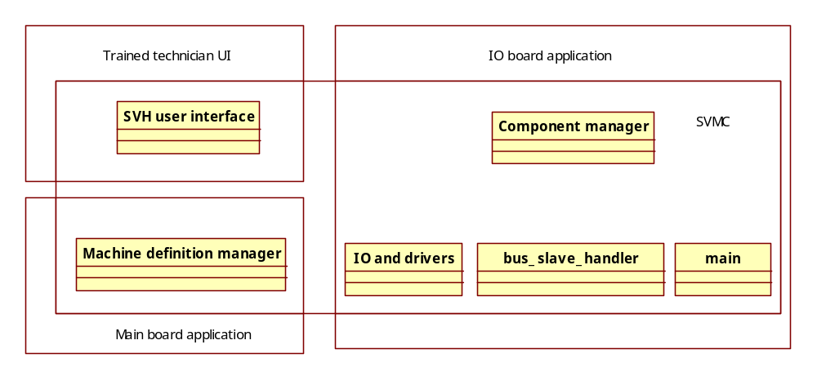
Figure 2

Figure 2 shows the modules for SVMC after improvement. There are three major changes for the improvement.

Firstly, simplify modules. Sessions, debuggers, BUS, SIH are removed. Sessions, debuggers tasks are for trace information. A test platform will be build and unit test will be performed for most modules, moreover online debug using ICE will be available. So the sessions and debuggers tasks can be removed. BUS task is no use anymore for there is no cup dispenser anymore. SIH’s job is only to start DBH; it can be removed either.

Secondly, SVH will be separated into 3 parts by functionalities. Machine definition manager will be moved to the main board application; User interface will be moved to trained technician UI; component manager will still stay in IO board application.

Thirdly, GWY, BDT, BOT tasks are replaced by bus_slave_handler task. Before improvement, the 485 communication framework is a complex asynchronous one. After improvement, IO board will do less work, needs less messages. A simpler synchronous framework will be developed.

Another improvement not shown in figure 2 is the improvement of boot and method of program update.

Test platform

SVMC code improvement will be developed separately with main board application’s code improvement. Code will be tested and merged iteratively. A test platform must be build to achieve this. On the test platform, developer can test and debug components and products without main board and administration applications.

There are 3 major steps to build test platform:

Step 1: test platform core

Overview

The test platform can be separated into two parts: test code on IO board and control program on PC.

In this step, the major task is to make minimal structure both for PC and IO board and let them talk to each other.
- On PC side (test UI): a program with only UI and new bus handler.
- On IO board side (IO application): a program with only main and new slave bus handler.
- In between two programs, a protocol and implementation will be define and developed.

The functionality of the test platform core is a smallest framework that can be able to communication between PC and IO board.

Plan

For convenience of develop and debug, the core of test platform will be develop on Windows and then move to IO board.

The PC test UI will use MFC to build dialog based UI. There is no user interactive dialog for test platform core.

Protocol is the way two unit communicate. Despite the low layer protocol handled by GWY, BUS and poll_task(), the protocol here is refer to the marshal/demarshal of component messages.

There are 4 steps to define and implement the protocol:
- describe the protocol in human language
- define a description for machine in non-ambiguity language
- parse and generate stub code for different program languages (C/C++)
- test

Implementation

The testAll project in /trunk/SVMC/test/testAll has Windows and Arm program which implement the test platform core.

An idl file is used to define the transmit data, the idl language definition is in /trunk/public/protocol/idl.txt

The idlparser project in /trunk/utils/idlparser is use to parse idl file and generate both C++ and C stub files.

All code in IO board is rewritten or refactoring and tested in /trunk/test/Serial/testSerialArm

Step 2: component test platform

Overview

The component test platform is based on the test platform core. It implements single component test and IO test.

The component test UI is test driven UI. It use several interface: report status, read key, etc. to define user interface. In component test platform, the PC side program will implement the simple test UI.

However, each component has its properties. Component test can not run without the properties. So a component properties UI and storage strategy must be designed to support component properties setting.

According to the SL15 software requirement document, most operator user interface including component test and adjustment setting UI will be moved to PC side. A PC program which connects to the main board program must be developed to fulfil this. So the connection prototype is PC UI connects to main board application, and then main board application connects to IO board application. That’s how the SL15 ultimate production looks like. However, the developers also need a convenience way to test components. So the test platform will merge the PC user interface into the main board test platform. After the all 3 steps of test platform done, the PC user interface can be easily move to another individual program.

Plan

Add additional ‘BUS’ task to main board application which simulates the communication between PC program and main board application.

Add a mock component with test functions and adjustment edit function.

Add new messages between IO board and main board application.

Add UI for test platform to edit and test mock component.

Implementation

The PC side project called AdjustmentEditor in /trunk/admin/AdjustmentEditor had been developed. The AdjustmentEditor implements most of the component relative UI in SL operator menu.

The component code is spitted into 3 parts: adjustment, gate and test/job
- Adjustment: /trunk/SVMC/test/testAdjCompMgr
- Gate: /trunk/GVMC/test/testGate
- Test/job: /trunk/SVMC/test/testAll/arm

Step 3: product test platform

Overview

The functionality of product test platform is close to the final program. Product can be made arbitrarily without main board connected.

A product producing process is combination of components actions. To make the components work in certain sequence, component job lists are needed. The component job lists are constructed according to machine configuration file called MDF. This process is called tree building.

After the SVMC software improvement, the tree building will be placed in main board application. The main board application will construct the components job lists, transmit them to IO board and tell IO board application to start making product.

The control program can receive error message and send cancel command to the IO board application.

Implementation

To make product, AdjustmentEditor adds product list on UI, user can select product and click run to make product. There are two entries: Fill boiler and Fill second boiler, are work as product and were added to the UI as special program.

MDF parser and product tree building are needed for making product. The test projects for them are located in /trunk/GVMC/test/SVH_TEST

The product running environment in IO board is completely rewritten. There are two test projects: testConnection and testCompRunner in /trunk/SVMC/test to test the connection and comp_runner environment. These two projects are Windows application. Connection and comp_runner is cross platform program. They can be tested in Windows and run in RTXC. To support the cross platform issues, the code in /trunk/public/platform had been refactoring for many times.

The final IO board projects are placed in /trunk/SVMC/test. There are several projects for different boards: testio for 75466, test468 for 75468 etc.

There are two ways AdjustmentEditor connecting to IO board: directly and through main board. This is implemented by BusMgr, Bus classes and applications running in main board. The source is located in /trunk/GVMC/BUS the test project located in /trunk/GVMC/test/testBus. The AdjustmentEditor can switch between these two connection ways by project configuration.

Software quality improvement
Software for product must be robust, tested, cohesion and clear. Moreover, for better software development, it should be extendable and reusable. Several aspects listed below describe how to improve the current SVMC software quality.

Clean up

Clean up unused code

The components in SL15 are based on SL code. There is code for history components which no used for current component. For example: FB cannister, error numbers like “IMxxx”. Error numbers is highly coupled to the user interface. There must be a unified error handing method which will be designed later on. But the unused error number must be cleared first.

Comment

Remove unused or incorrect comments. Add necessary comments, especially for unnamed const data, like delay_ms(MSEC_1) call.

Naming

The naming must follow the C_C++ coding convention.doc. Variables’, parameters’ and functions’ names must represent exactly what they mean.

Format

The code format must be consistent through files. MS visual studio is recommended for auto formatting editor.

Make code high cohesion

Cohesion is a measure of how strongly-related or focused the responsibilities of a single class, function or module are. In object-oriented programming, if the methods that serve the given class tend to be similar in many aspects the class is said to have high cohesion. In a highly-cohesive system, code readability and the likelihood of reuse is increased, while complexity is kept manageable.
Cohesion is decreased if:
- The responsibilities (methods) of a class have little in common.
- Methods carry out many varied activities, often using coarsely-grained or unrelated sets of data.

Disadvantages of low cohesion (or "weak cohesion") are:
- Increased difficulty in understanding modules.
- Increased difficulty in maintaining a system, because logical changes in the domain affect multiple modules, and because changes in one module require changes in related modules.
- Increased difficulty in reusing a module because most applications won’t need the random set of operations provided by a module.

In SL15 C code, to make code higher cohesion, several steps must be taken to refactoring.
- Components’ code must be reviewed line by line. The document: How do components work.doc should be consistent to the real component action. Some functions, like heating and cooling monitor threads should be refactoring.
- For files, remove unused dependencies.
- For functions, less global variable should be used, pass it as argument. Split, join, rename functions, etc.
- For global variables, they should be redesigned.

Thread safe code

Thread, namely task in RTXC, is widely used in SVMC. Thread should be used carefully. All cross thread resources should be protected. There are many variables using by multiply threads are not protected.

Additional OS API abstract layer

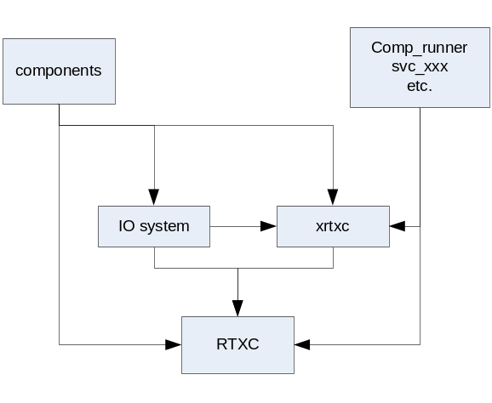

The above figure describes the SVMC module dependency before improvement. Most modules rely on the RTXC. But there are some modules need to be developed and tested under windows and run on RTXC. So the Windows application must include and implement RTXC APIs. These modules are comp_runner, connections, etc.

Portable software architecture should not rely on any OS. As the flowing figure shows, an additional OS API abstract layer is introduced. The code could switch from RTXC, WIN or any other OS easily. Portable software is easier for test, development, and is more robust. These advantages are proved by projects like: testConnection, testCompRunner, etc.

Portable software is adaptable to future needs. The whole system (current main/IO board) may be in one board for compact machine. The whole system might need to migrate to CE or to RTXC. Without OS API abstract layer, it is difficult to achieve this goal.

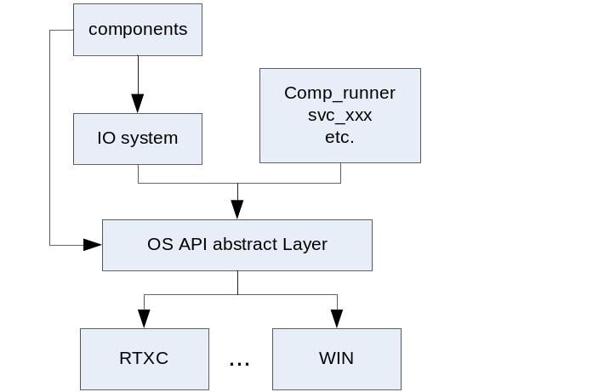

Develop with C++

Using C++ will dramatically improve the source size, code reusing, development tools, etc.

There are two major problems with C++ development for Keil IDE: construction call and malloc problem.
- Construction functions are not called by default startup.s, new code must add to call C++ default construction sections at boot.
- Malloc are ignored by default CLib of gcc shipped with Keil. Hence the new/delete can not be used. A full functional CLib (eg. Winarm) must be used to support this.

IO board Software update

<<To be modified>>

IO board Software update is dynamically download new version of software to IO board.

Before improvement

Before SVMC software improvement, the software in IO board consists of two applications: so called boot loader and IO application.

The major job for boot loader is update IO application. The boot loader uses a complicated protocol called COM30 talking with software in PC called CL-Serv to update IO application.

Boot loader is actually an application too. Boot loader and IO application use different source tree. No codes are reused.

After improvement

The download part and boot part of the boot loader and IO application use the same source code. Boot loader and IO application can download each other. After improvement, the code size is much smaller. The IO board application code is about 100k and boot loader code would be less than 20k. There is 256K in chip flash MCU. So code reuse is acceptable.

The complex COM30 protocol will be removed from the boot loader. Another simple protocol will replace COM30.

A test program will be added to the boot loader for factory test. When the IO board’s PCBA is produced by factory, a boot loader program will be burned into the IO board. The IO application will be downloaded to the IO board at machine assembly time. The PCBA factory will use a fixture platform to test the IO functionalities of IO board; that is when the test program works.

Implementation

To be added…

